**Hong Kong Institute of Vocational Education (Tsing Yi)**

**Discipline of Information Technology**

**HD in Game Software Development (IT114107)**

**ITP4913M Final Year Project**  
**(2021/2022)**

**Catching the Naughty Kids**

**3D Teacher Simulator Game**

|  |  |
| --- | --- |
| **Supervisor:** | Edmund Chiu |
| **Co-supervisor:** | Nanoka |
| **Student:** | Law Cheuk Hung  Leung Yiu Fung  Chan Hung Chun  Sham Ka Hon |

We declare that this is a group project and that no part of this submission has been copied from any other student’s work or from any other source except where due acknowledgement is made explicitly in the text, nor has any part been written for us by another person.

|  |  |  |
| --- | --- | --- |
| **Student** | **Contribution to the project (%)**  **(Total 100%)** | **Signature** |
| Law Cheuk Hung | **25%** |  |
| Leung Yiu Fung | **25%** |  |
| Chan Hung Chun | **25%** |  |
| Shum Ka Hon | **25%** |  |

# **Abstract:**

This report describes a game development project which about a 3D style secondary school teacher simulation game. This report describes the very begin idea and the requirements that should be consider. Besides, this report describes the game plot, the major game play, and the game art style. It will go a low vertex style which provide some draft pictures for reference.

# **Table of Content**

Abstract: 2

Table of Content 2

Introduction 2

Task that we are going to gamify: 2

The game that we are going to develop: 2

Game Design 2

Design Thinking – Basic constraints and requirements 2

Design Thinking – Empathize & Define 2

Design Thinking – Ideate 2

# **Introduction**

## **Task that we are going to gamify:**

In recent years, there are many Hong Kong school teachers they resigned from their working school and immigrant to other countries. This phenomenon leads to the problem that some of the schools occurring the shortage of faculty and the inappropriate arrangement of teaching plan schedule. These schools could not assign enough teachers to handle the classes. Some of the teachers might be assigned unreasonable workloads for minimize the impact of the faculty shortage.

So, for soothing the problem, we want to make a game to attract the public that participate into the educational career. The target group of this promotion is the fresh-graduated college students. They have enough subject’s knowledge, less generation gap and enough social awareness that can teach and enlighten the students. In this game, the public can experience the duties of being a secondary school’s teacher. Some of the elements in this game can touch them to become a good educator.

## **The game that we are going to develop:**

Our project supposed to design a 3D simulator game which about being a secondary teacher. The player will role play a teacher in first person view to handle the class order and conduct the lesson. This game is mainly playing as a single game. But we would like to apply some of the multi-player elements and leaderboard. It can increase the joy of this game. This game will run in PC platform with window system. We may also add a mobile app for the player to check the leaderboard and compare to their friends. We expect that the public can know more about the duties and responsibilities of being a teacher.

# **Game Design**

## **Design Thinking – Basic constraints and requirements**

This game supposed to be finished in 6 months which means it would be finished in April of 2022.

In first 3 months, we decided to build the first scene of the game. It would be a normal class which contains some of the equipment like students chairs and tables, black board, shelf, locker, etc. Besides, we decide to make our own character models by ourselves. For the students’ model, we would use the 3DMax tool to build some low vertex students which contains some motion such as stretch hands to left or right (texting with neighbor or cheating), lying on the table (sleeping), swing hands (making noise), etc. For the teacher’s model, we would not design the whole teacher’s model because the game is play as first-person game, we do not need the whole model of the teacher. Instead, we just design the hands only model with motion for the teacher. The teacher’s motion may include flipping book (teaching mode), clapping hands (special skills), grabbing (catch naughty students).

In last 3 months, we supposed to build a client-server-database to store the player id and password. The database will also store the total highest score gains from each single level of the game. We would like to design at least 2 levels of game. The player can check the leaderboard that reference from the database’s data. About the leaderboard, we would like to design a simple mobile application for the players to check their score. Besides, we would like to design a multiplayer system in the game. The players can challenge with friends in real time. So, the server building is necessary. For furthermore, we would like to apply the VR system to the game. The player can use the VR equipment like VR glasses and remote controllers to play the game. So, we might have to familiarize with the VR system design.

## **Design Thinking – Empathize & Define**

Our project is going to design a classroom lesson simulator game in Hong Kong secondary school.

First, we should be supposed to build an environment that like the Hong Kong classroom. For example, this game is about to catch the bad students, but how these students use the classroom equipment to cheat or do other bad action. The equipment in the classroom may be the important parts should be implemented in our game. We cannot go too far from the actual vision of the Hong Kong schools’ classroom. Otherwise, it will affect the devotion of the players. So, we may need to reference from some of the classroom in Hong Kong. Also, we need to brain-storm the interaction between the classroom equipment and the students. If we could make it, it can let the game more dynamic and interesting.

Second, we should be supposed to understand the flow of how a teacher run a lesson. The player is supposed to familiarize the teacher’s duties and responsibility. But if we designed it too far from the actual situation of a regular lesson in Hong Kong secondary school, it would mislead the player that get a wrong impression of being a teacher.

Third, we expect that the characters’ movements design will be the most challenging part of this project. In this game, the player needs to observe the students' movements and determine which behavior is considered as illegal in the lesson or examination. So, we need to put more effort into designing 3D model movements. More different movements will increase dynamics and interest of this game.

## **Design Thinking – Ideate**

In the beginning, we thought that we can make a mobile game with role-play topic. With this idea, we thought that we can put more effort in the art design. We can create many characters that the player can collect. The player can explore the maps to unlock the story plot and the new adventure partners. Also, we had considered that we can build a store system. The player can draw powerful characters with spending the items that collect from the game. This system can stick the player into our game because it has the lucky draw element which can attract the humans’ desire of occupancy.

But after we give a deep consideration, we want to make a game that can inspire the public about some of the occupation in the society such as teacher. We finally decide to make a simulation game about being a teacher. We have notice that the simulation game may attract the public to experience different jobs. They may learn more about the situation and duty of some industries. Also, we have considered to apply the VR technology in our game. If we can fulfil this idea, it may be another unique selling point for attract the player.

# **Game Overview**

## **Story background:**

There is a secondary school that they are well-known in educational industry. Their strategy is accepting all students either they are good or bad behaved students. This decision leads to the consequence that most of the bad students would be arranged to this school, because there are no other schools want to accept them. Some of these students may just not good in studying, but some may also have bad behaviors like cheating or destroying the studying atmosphere in school. They are troublesome to many teachers in this school.

In this game, the player will role played as a new teacher in this school. They will be assigned to teach in many classes, some classes may be easy to handle, but some may be hard to deal with. In the class, the bad students will randomly issue many incidents like cheating, eating, or texting.

The main mission of player is to maintain the class order like catching the bad students. Also, they should make sure that there are enough textbook’s contents have been taught.

Apart from the lesson section, there will also are a after lesson’s part that the player should enlighten the bad students to correct their fault. The player needs to choose different dialogs or action to deal with the students. This part may affect the player’s attributes that they can have more skills to handle the upcoming classes (levels).

## **Play modes:**

Single-play Mode:

This play mode is concentrating in the story mode. The player can experience the story and interact with the game AI.

Multi-play Mode:

This play mode is concentrating in the unity game server and networking representation. The player can create a game room and share the room id to their friends. In this game mode, there are around two or three players will join to the same game room. They should compete the speed and the completion of the tasks in the game. After the game is ended, the system will calculate the leaderboard which shows the total marks.

**System Architecture:**

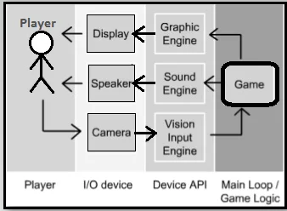

# **Game World**

## **Game Environment:**

Our game’s main vision is the classroom with the nature light spreading from the sun.

## **Level Design:**

In the first lesson, the player will need to finish tasks and forces on teaching level only. When entering the second lesson, the player will be required to complete the mission and tasks. Also, the player needs to handle time management, teaching level and take care of students in this classroom. Otherwise, the player will lose control in this lesson or lose at this level.

However, when the player enters advanced level, game items will be provided to player for deal with different actions or behaviors of students and different event.

## **Maps Design:**

The main scene will design as a secondary school’s classroom.

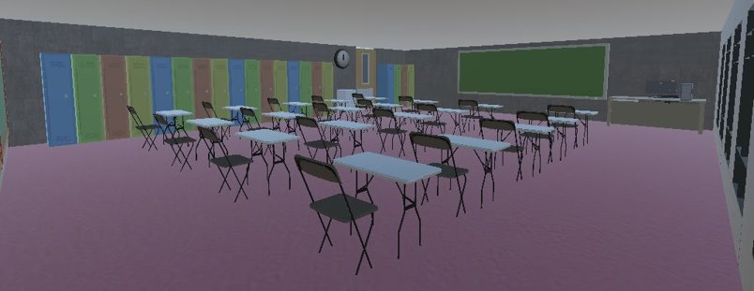

# **Gameplay Description**

## **Basic Game Play:**

The player will play as a teacher to hold a lesson in the class. During the lesson, the students will randomly issue some of the incidents that affecting the lesson proceeding. The player needs to find out which student has behaved badly. Also, the player should make sure the teaching schedule has been covered.

At game start, the game will assign some mission to player need to finish the task that is shown on the Task list. When the game is in progress, students will act badly when the player focuses on the task. Players need to find out and solve the students. If not, it would affect player task progress. Player will lose when the player fails to complete the task before the time limit.

# **Software Design**

Use Case Diagram:

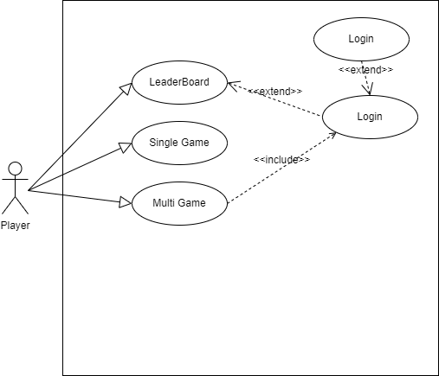

Class Diagram:

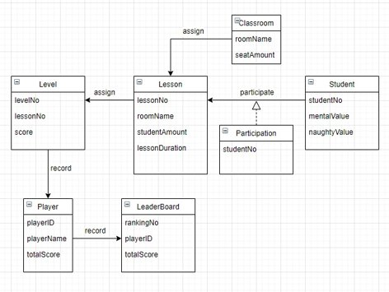

# **Hardware and Software Requirements**

**[Hardware]**

**Game Running:**

PC System Requirements

OS: 64-bit Windows 7.

CPU: Intel Core i3-6300 3.8GHz / AMD FX-4350 4.2 GHz Quad-Core Processor.

RAM: 6GB.

GPU: NVIDIA GeForce GT 640 / Radeon HD 7730.

GPU RAM: 1 GB.

HARD DRIVE: Minimum 22 GB of free space.

**Leaderboard:**

Smartphone with android system

**VR Technology (optional):**

HTC VIVE Cosmos Elite

* Head equipment (Glasses and headphone)
* Remote (left and right hands control)

**[Software]**

**Game Engine:**

We decide to use the Unity of 2019.4.24f1 version to design our game. But if we consider applying the VR technology in our game, the 2020 version of Unity maybe better. But for the first step, we may use the 2019 version to build up most scene and game mechanic. After we decide to use VR, we may translate the whole project to 2020 version for further development.

**Model Design tools:**

We decide to use 3DMax to design our characters (students, teacher’s hands), scenes’ equipment (chair, shelf) and items (teacher’s book, students’ book, cheating paper, smartphone).

# **Technical Considerations**

In this project, we majorly apply 3 technical items in our game.

First, we decide to apply the multi-player system, we are studying about the Unity networking implement which call Photon Unity Networking2 (PUN2). The extension of unity service is for the game developer to make a server that allow players with different IP to join the same game room for playing. We need to study how to make a user interface for the players choose which game type they want to play (single game for story mode, multiple game for friends’ battle).

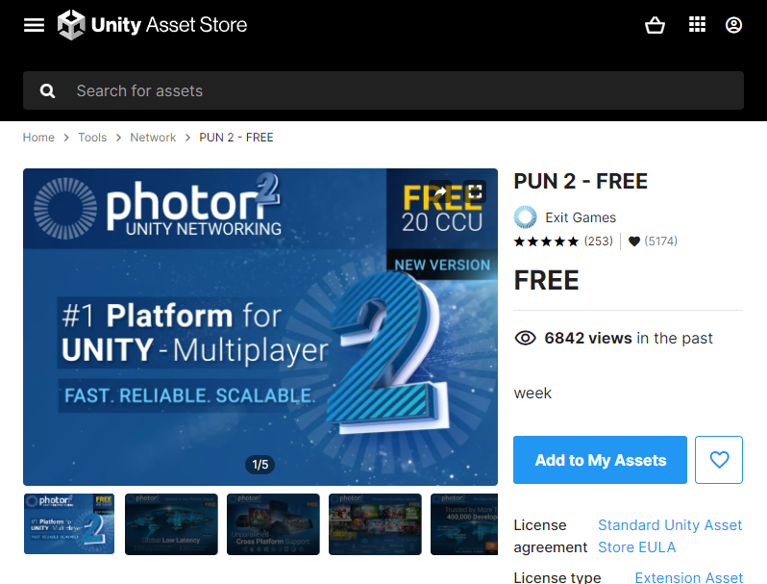

Second, we decide to build a database system for storing the player’s statistics. When we were designing our game, we want to give some award or feedback to the player, such as total score getting from the game. So, we want to build a leaderboard for the players. The player can get a good score from the game when they did a well play in the single game. The players can compare their score with their friends. It can increase the joy of our game.

Third, we decide to build a similar AI system in our game. We thought that if we increase the unpredictable elements in our game, it can make our game to be more “playable”. In our game, we are going to design a similar AI system for the students (Non-Player Character). Each time the player opens a new game, it will generate different attributes for the students, the player can face different situation when they are playing.

# **Project Plan**

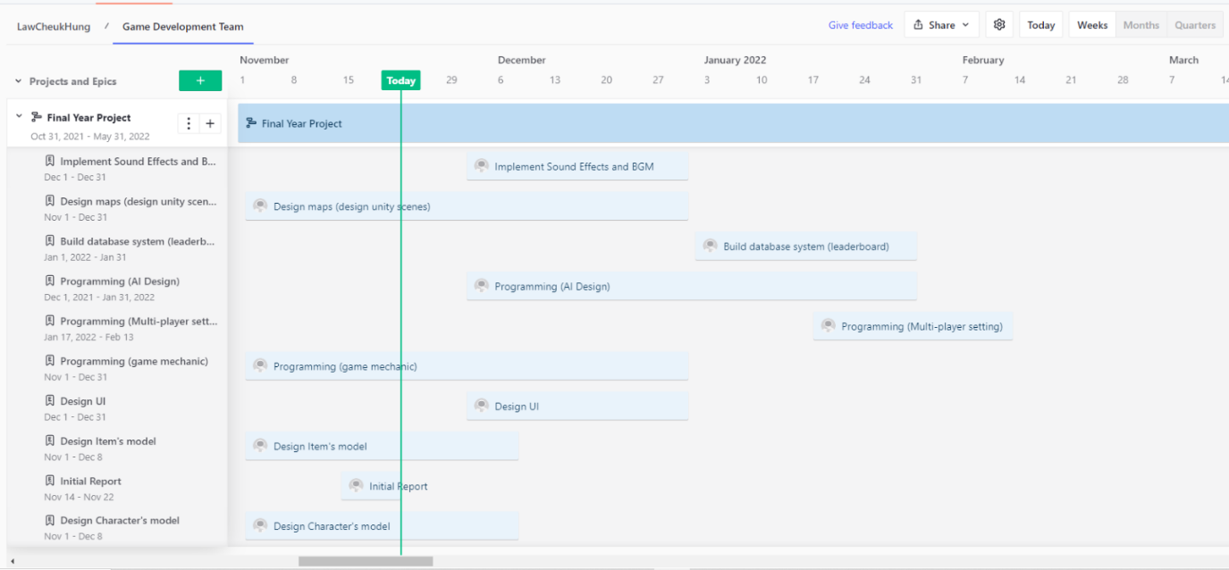

# **References**

For the game art style, this game will be developed in a simple graphic and cartoon-like art style. We want to make this game in a low vertex and low detailed art style. It can represent a simple and clear vision for the player, but relatively, the player can be easy to recognize the objects in the game.

Reference from the game (Human Fall Flat):

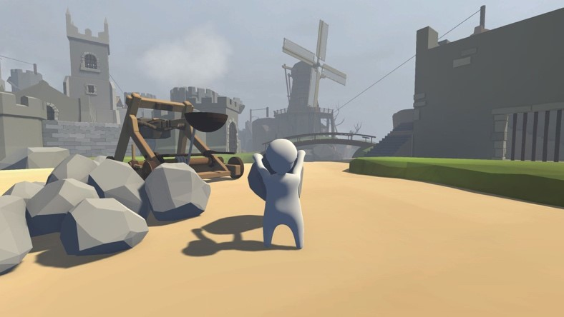

Reference from Euro Truck Simulator 2:

This game is found from the market of simulator game, this game is simulated that the truck driver that deliver the products to different place in Euro. This game designed a map that referenced the actual euro’s road design. It also references from the actual truck control and main vision of controlling a truck in real.

# **Appendices**

## **Work Distribution:**

(Law Cheuk Hung)

Character logic design (coding):

1. Teacher architecture

2. Student architecture

(Chan Hung Chun + Shum Ka Hon)

Character model and animation design:

1. Teacher (only hands)

2. Students

(Shum Ka Hon + Leung Yiu Fung)

Object model design:

1. Player interactable objects

2. Classroom equipment

(Leung Yiu Fung)

Scene design:

1. Level design

(Chan Hung Chun)

UI design (with coding):

1. Interactable column

2. Task system

## **Budget Estimation:**

We may expect that we will spend around 100 HKD in the soundtrack and background music part. But for the model, game engine, 3D model design or the further technology applying (VR), we can use the free sources that provide by the company and VTC institution.

## **Log Sheet:**

**Hong Kong Institute of Vocational Education Discipline of Information Technology Final Year Project - Log Sheet (No.** **)**

|  |  |
| --- | --- |
| Course/Class: | Project Group: |
| Supervisor: Edmund Chiu | Date: |
| Project Title: Catching the Naughty Kids |  |
| Student Name(s): Leung Yiu Fung |  |

|  |  |  |  |
| --- | --- | --- | --- |
| Work done & findings since last recording | | Logged by | |
| Designed scenes of game | |  | |
| State which part of the last plan not yet finished (leave it blank if you finished all the work of the last plan | | Logged by | |
| Draw game ui    Design game level not yet finished | |  | |
| Plan of work before the next recording | | Logged by | |
| Designed game level | |  | |
|  |  | |
|  |  | |

|  |  |  |
| --- | --- | --- |
| Student’s Signature: |  | Supervisor Signature |

**Hong Kong Institute of Vocational Education**

**Discipline of Information Technology**

**Final Year Project - Log Sheet (No. )**

|  |  |
| --- | --- |
| Course/Class: __ITP114107______ | Project Group: _A4__ |
| Supervisor: __Mr. Edmund Chiu____ | Date: __11/01/2022______ |
| Project Title: __Catch the Naughty Kids_____________ | |
| Student Name(s): __Law Cheuk Hung___________________ | |

|  |  |
| --- | --- |
| Work done & findings since last recording | Logged by |
| The player behavior and student behavior  The student’s info showing to player’s camera  The mission system  The UI Information showing system |  |
| State which part of the last plan not yet finished (leave it blank if you finished all the work of the last plan | Logged by |
| Player skills system  Implement more side mission for player  Implement more interactive items to player  Main Menu & UI system |  |
| Plan of work before the next recording | Logged by |
| Multiplayer system  Database system  Cut scenes & dialogue game |  |

|  |
| --- |
| Supervisor’s comment on student’s work |
|  |

|  |  |  |
| --- | --- | --- |
| Student’s Signature:   |  | Supervisor Signature |